**Name: …………………………………………..**

**Topic: 9B – Plant Growth**

Title: Photosynthesis – Limiting Factors

**TASK 1: Summarise photosynthesis**



……Photosynthesis is a chemical reaction between water and carbon dioxide to create oxygen and glucose (its own food). This required sunlight and chlorophyll…………………………………………………………………………………………………………………………………………………………………………………………………………………………………………………………………………………………………………………………………………………………………………………………………………………………………………………………………………………………………………………………………………………………………………………………………………………………………………………………………………………………………………………………………………………



**TASK 2: On Investigation Sheet**

**TASK 3: Single data analysis**

The rate of photosynthesis will speed up producing more oxygen and glucose however if too much light is produced, the light’s heat will damage the plant……………………………………………………………………………………………………………………………………………………………………………………………………………………………………………………………………………………………………………………………………………………………………………………………………………………………………………………………………………………………………………………………………………………………………………………………………………………………………………………………………………………………………………………………………………………………………………………………………………………………………………………………………………………………………………………………………………………………………………………………………………………………………………………………………………………………………………………………………………………………………………………………………………………………………………………………………………………………………………………………………………………………………………………………………………………………………………………………………………………………………………………………………………………………………………………………………………………………………………………………………………………………………



……………………………………………………………………………………………………………………………………………………………………………………………………………………………………………………………………………………………………………………………………………………………………………………………………………………………………………………………………………………………………………………………………………………………………………………………………………………………………………………………………………………………………………………………………………………………………………………………………………………………………………………………………………………………………………………………………………………………………………………………………………………………………………………………………………………………………………………………………………………………………………………………………………………………………………………………………………………………………………………………………………………………………………………………………………………………………………………………………………………………………………………………………………………………………………………………………………………………………………………………………………………………………

**Questions**

**Q1.**

(a)     Complete the equation for photosynthesis. Draw a ring around each correct answer.

|  |  |  |  |  |  |  |
| --- | --- | --- | --- | --- | --- | --- |
|  |  | hydrogen |  | alcohol |  |  |
| Carbon dioxide | + | nitrogen | light energy | glucose | + | oxygen |
|  |  | water |  | methane |  |  |

**(2)**

Some students investigated the effect of light intensity on the rate of photosynthesis in pondweed.

The diagram shows the apparatus the students used.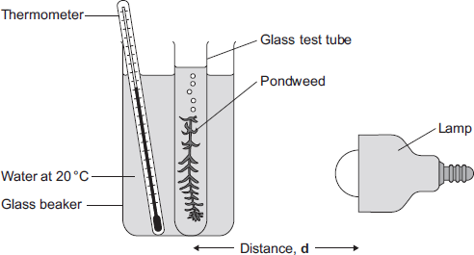

The closer the lamp is to the pondweed, the more light the pondweed receives.

The students placed the lamp at different distances, **d**, from the pondweed.

They counted the number of bubbles of gas released from the pondweed in 1 minute for each distance.

(b)     A thermometer was placed in the glass beaker.

Why was it important to use a thermometer in this investigation?

So they keep track of the temperature so that the plants don’t get damaged

........................................................................................................................

........................................................................................................................

........................................................................................................................

........................................................................................................................

........................................................................................................................

........................................................................................................................

**(3)**

(c)     The students counted the bubbles four times at each distance and calculated the correct mean value of their results.

The table shows the students’ results.

|  |  |  |  |  |  |
| --- | --- | --- | --- | --- | --- |
| **Distance d in cm** | **Number of bubbles per minute** | | | | |
| **1** | **2** | **3** | **4** | **Mean** |
| 10 | 52 | 52 | 54 | 54 | 53 |
| 20 | 49 | 51 | 48 | 52 | 50 |
| 30 | 32 | 30 | 27 | 31 | 30 |
| 40 | 30 | 10 | 9 | 11 |  |

(i)      Calculate the mean number of bubbles released per minute when the lamp was 40 cm from the pondweed.

..............................................................60/4=15.................................................

...............................................................................................................

Mean number of bubbles at 40 cm = .........15...................................

**(2)**

(ii)     On the graph paper below, draw a graph to show the students’ results:

•        add a label to the vertical axis  
•        plot the **mean values** of the number of bubbles  
•        draw a line of best fit.

                  Distance **d** in cm

**(4)**

(iii)    One student concluded that the rate of photosynthesis was inversely proportional to the distance of the lamp from the plant.

Does the data support this conclusion?

Explain your answer.

Yes, because the at 10 meters, the bubbles went up to 4 bubbles per minute 54 times. While at 40 meters, it was only 1 bubble per minute 30 times...............................................................................................................

...............................................................................................................

...............................................................................................................

...............................................................................................................

...............................................................................................................

...............................................................................................................

**(2)**

(d)     Light intensity, temperature and concentration of carbon dioxide are factors that affect the rate of photosynthesis.

Scientists investigated the effects of these three factors on the rate of photosynthesis in tomato plants growing in a greenhouse.

The graph below shows the scientists’ results.

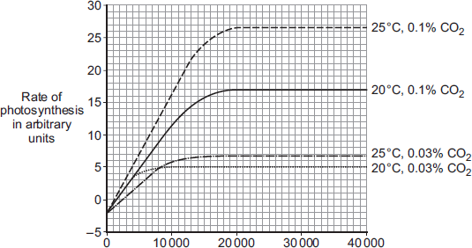  
Light intensity in lux

A farmer in the UK wants to grow tomatoes commercially in a greenhouse.

The farmer read about the scientists’ investigation.

During the growing season for tomatoes in the UK, natural daylight has an intensity higher than 30 000 lux.

The farmer therefore decided to use the following conditions in his greenhouse during the day:

•        20°C

•        0.1% CO2

•        no extra lighting.

Suggest why the farmer decided to use these conditions for growing the tomatoes.

You should use information from the scientists’ graph in your answer.

........................................................................................................................

........................................................................................................................

........................................................................................................................

........................................................................................................................

........................................................................................................................

........................................................................................................................

........................................................................................................................

........................................................................................................................

........................................................................................................................

........................................................................................................................

........................................................................................................................ **(4)**

**(Total 17 marks)**